INSTITUTION LOGO

YOUR COMPANY NAME

PREPARED BY:

SUPERVISED BY:

Contents

1.0 Executive Summary 3

2.0 Purpose of Business Plan 5

3.0 Company Background 6

3.1 Company’s Profile 6

3.2 Vision and Mission 7

3.3 Rational Prospection 8

3.3.1 Company Location 8

3.3.2 Facilities 8

3.3.3 Physical Position 8

4.0 Owners/Worker’s Profile 9

5.0 Marketing plan 10

5.1 Goods and Services 10

5.2 Target Market 12

5.3 Market Size 13

5.4 Company Market Segment 13

5.5 Competitors 14

5.6 Market Share 15

5.7 Marketing Strategy 16

5.8 Sale Forecasting 18

6.0 Operation plan 20

6.1 Based Description 20

6.2 Equipment 20

6.3 Manufacturing Process 21

6.3.1 Revenue 21

6.3.2 Customer 21

7.0 Organization’s aspect 22

7.1 Organization Structure 22

7.2 List of Workers 22

7.3 Job Scope 23

8.0 Financial plan 24

8.1 Cost of Project 24

8.2 In-Capital 24

8.3 Set-Up Cost 25

8.4 Working Capital 26

8.5 Loan Amortization 27

8.6 Depreciation 27

8.7 Cash Flow Statement 29

8.8 Balance Sheet 29

9.0 Appendixes 30

# EXECUTIVE SUMMARY

**The reason for choosing the business**

(Overview, problem, solution, team capacity, expectation)

# Purpose of Business Plan

**Guideline / Strategy**

**Road Map**

**Sales Tool**

# Company Background

## Company’s Profile

**Company’s Name :**

**Company’s Address :**

**Company’s email :**

**Company’s Website :**

**Company’s Phone No. :**

**Company’s Fax No. :**

**Form of Business :**

**Type of Business :**

**Main Activity :**

**Date of Business Commencement :**

**Operational Date :**

**Initial Capital :**

**Bank Issue :**

**No. Company’s Bank Account :**

## Vision and Mission

**Vision**

**Mission**

## Value Proposition

## Rational Prospection

### Company Location

### Facilities

### Physical Position

## Owners/Worker’s Profile & Qualifications

|  |  |  |
| --- | --- | --- |
| **No.** | **Name** | **Detail** |
| 1 |  | DATE OF BIRTH :  AGE:  GENDER:  ADDRESS:  PHONE NO:  MARITAL STATUS:  QUALIFICATIONS: |
| 2 |  |  |
| 3 |  |  |
| 4 |  |  |
| 5 |  |  |

# Marketing plan

## Goods and Services

## Target Market

## Market Size

## Company Market Segment

## Competitors

## Market Share

## Marketing Mix (4Ps)

## Sale Forecasting

# Operation plan

## Based Description

## Equipment

|  |  |  |  |
| --- | --- | --- | --- |
| NO | ITEM | PRICE (RM) | FINANCIAL TYPE |
| 1 | Computer and Website Cost |  |  |
| 2 |  |  |  |
| 3 |  |  |  |
| 4 |  |  |  |
| 5 |  |  |  |
| 6 |  |  |  |
| 7 |  |  |  |
| 8 |  |  |  |

## Manufacturing Process/ Inventory Planning

### Material Planning

### Capacity Planning

### Process flow

### Layout plan

# Organization’s aspect

## Organization Structure

Please insert your organization chart here

## List of Workers

|  |  |  |  |  |  |
| --- | --- | --- | --- | --- | --- |
| NO. | POSITION | NO. | MONTHLY SALARY (RM) | EPF (13%) (RM) | TOTAL (RM) |
| 1 |  |  |  |  |  |
| 2 |  |  |  |  |  |
| 3 |  |  |  |  |  |
| 4 |  |  |  |  |  |
| 5 |  |  |  |  |  |
| TOTAL | |  |  |  |  |

## Job Scope

|  |  |
| --- | --- |
| **POSITION** | **RESPONSIBILITY** |
|  |  |
|  |
|  |
|  |
|  |  |
|  |
|  |
|  |
|  |
|  |  |
|  |
|  |  |
|  |
|  |  |

# Financial plan (guna slide template)

## Project Implementation Cost

**Guidelines:**

The project implementation cost includes all the costs needed to start the business, such as cost of assets (i.e. cost of equipment, renovation, furniture, etc.) plus working capital (i.e. cost of salary, rental, raw material, etc.) plus other miscellaneous items (i.e. business registration, rental deposit, contingencies, etc.).

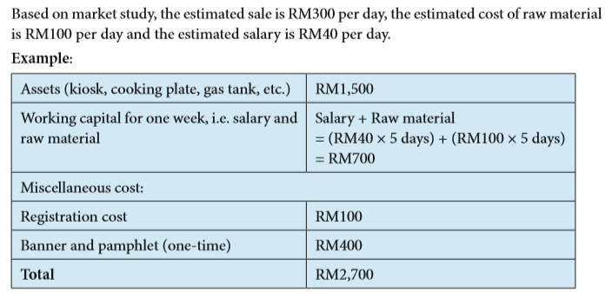

### Fixed Assets / Set-Up Cost/ Pre Operating Cost / Initial Cost (1st monthly)

|  |  |  |  |
| --- | --- | --- | --- |
| NO | ITEM | PRICE (RM) | FINANCIAL TYPE |
| 1 | Computer |  |  |
| 2 |  |  |  |
| 3 |  |  |  |
| 4 |  |  |  |
| 5 |  |  |  |
| 6 |  |  |  |
| 7 |  |  |  |
| 8 |  |  |  |
| 9 |  |  |  |
| 10 |  |  |  |
| 11 |  |  |  |
| Total | | | RM |

Total 1st month cost:

Assets/ Initial cost : RM

Bank Loan : RM

**RM**

### Working Capital

|  |  |  |
| --- | --- | --- |
| **Type of expenditure** | **RM** | **RM** |
| Marketing expense |  |  |
| Promotion  (RM*1 month) |  |  |
|  |  |  |
|  |  |  |
|  |  |  |
|  |  |  |
|  |  |  |
|  |  |  |
|  |  |  |
|  |  |  |
|  |  |  |
|  |  |  |
|  |  |  |
|  |  |  |
| Total | |  |

### Project Implementation Cost

|  |  |  |
| --- | --- | --- |
| 1 | Fixed Assets and Initial Cost |  |
| 2 | Working Capital |  |
| **Total** | |  |
| 3 | Unexpected Expenditure/ Contigency (%) |  |
| **Grand Total** | |  |

## Capital (Modal perniagaan)

**Guidelines:**

Sources of the fund are the sources of money to be capitalized for the business; normally from the owner’s money and borrowings.

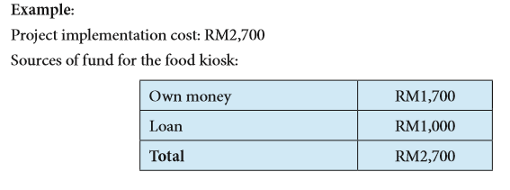

1. Owner/Board of Director Capital : RM
2. Bank Loan : RM

Total Starting Capital : RM

## Project Implementation Cost & Sources of Fund

**Guidelines/Example:**

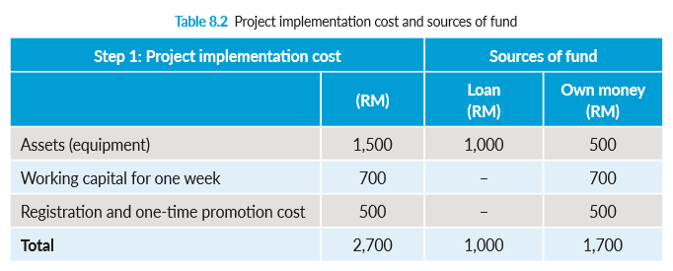

|  |  |  |  |
| --- | --- | --- | --- |
| **Project Implementation Cost** | | **Sources of fund** | |
|  | **RM** | **Loan (RM)** | **Own money (RM)** |
|  |  |  |  |
|  |  |  |  |
|  |  |  |  |
| **Total** |  |  |  |

## Loan Amortization & Depreciation Value

**Guidelines/Example:**

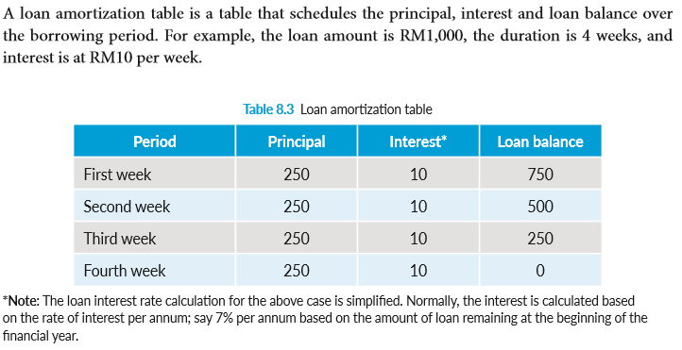

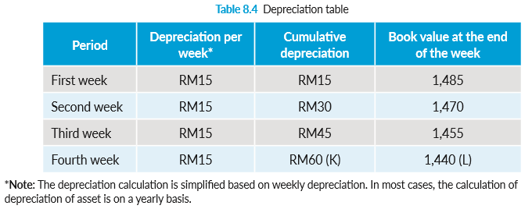

Total Loan : RM ___________

Interest rate : ______ %

Payback Years : _______ years

|  |  |  |  |  |
| --- | --- | --- | --- | --- |
| Year | Interest | Principal | Total Repayment | Current Balance  (RM) |
| 0 |  |  |  |  |
| 1 |  |  |  |  |
| 2 |  |  |  |  |
| 3 |  |  |  |  |
| 4 |  |  |  |  |
| 5 |  |  |  |  |
| 6 |  |  |  |  |
| 7 |  |  |  |  |
| 8 |  |  |  |  |
| 9 |  |  |  |  |
| 10 |  |  |  |  |
| 11 |  |  |  |  |
| 12 |  |  |  |  |
| 13 |  |  |  |  |
| 14 |  |  |  |  |
| 15 |  |  |  |  |
| TOTAL |  |  |  |  |

Annual interest= * RM

Annual principal = RM

Total annual repayment (for year) RM

Total monthly repayment (for year) = RM

Total annual repayment (for year) RM

Total monthly repayment (for year) = RM

## Depreciation

Asset Name : Machines and Equipment

Furniture and Others

Purchase Cost : RM

Lifespan : years

|  |  |  |  |
| --- | --- | --- | --- |
| **Year** | **Annual Depreciation** | **Accumulated Depreciation** | **Book Value** |
| 0 |  |  |  |
| 1 |  |  |  |
| 2 |  |  |  |
| 3 |  |  |  |
| 4 |  |  |  |
| 5 |  |  |  |
| 6 |  |  |  |
| 7 |  |  |  |
| 8 |  |  |  |
| 9 |  |  |  |
| 10 |  |  |  |

Annual Depreciation = RM

= RM

Monthly Depreciation = RM

= RM

## Pro-forma Cash Flow Statement

**Guidelines/Example:**

|  |  |  |  |  |  |  |  |  |  |  |  |  |  |  |
| --- | --- | --- | --- | --- | --- | --- | --- | --- | --- | --- | --- | --- | --- | --- |
| **Monthly cash flow projection** | **Pre-operation** | **1st month** | **2nd month** | **3rd month** | **4th month** | **5th month** | **6th month** | **7th month** | **8th month** | **9th month** | **10th month** | **11th month** | **12th month** | **Total** |
| Balance from previous month | **0.00** | 12032.10 | 9023.28 | 7898.29 | 8192.63 | 9906.31 | 13039.31 | 17591.65 | 23563.31 | 29689.81 | 35816.31 | 41942.81 | 48069.31 |  |
| Own capital invested (from 'Sources of funds' sheet) | **49944.80** |  |  |  |  |  |  |  |  |  |  |  |  | **49944.80** |
| Loan (from 'Sources of funds' sheet) | **15000.00** |  |  |  |  |  |  |  |  |  |  |  |  | **15000.00** |
| Forecast of monthly sales (varied seasonally from month to month) as a percentage of average monthly sales forecasted | **0.00** | **40%** | 50% | 60% | 70% | 80% | 90% | 100% | 100% | 100% | 100% | 100% | 100% |  |
| Projected monthly sales (in RM based on the above seasonal forecast) |  | **10322.40** | 12903.00 | 15483.60 | 18064.20 | 20644.80 | 23225.40 | 25806.00 | 25806.00 | 25806.00 | 25806.00 | 25806.00 | 25806.00 | **255479.40** |
| Percentage of cash sale (*Note: credit sale will be calculated as account receivable below*) | **80%** | 8257.92 | 10322.40 | 12386.88 | 14451.36 | 16515.84 | 18580.32 | 20644.80 | 20644.80 | 20644.80 | 20644.80 | 20644.80 | 20644.80 | **204383.52** |
| Percentage of account receivable collected from previous month | **20%** | 0.00 | 2064.48 | 2580.60 | 3096.72 | 3612.84 | 4128.96 | 4645.08 | 5161.20 | 5161.20 | 5161.20 | 5161.20 | 5161.20 | **45934.68** |
| Estimate percentage of cost of direct material over total monthly sale (from monthly budget C4) | **35%** |  |  |  |  |  |  |  |  |  |  |  |  |  |
| Cost of direct material on percentage of sales above row B9 (RM) |  | **3612.84** | 4516.05 | 5419.26 | 6322.47 | 7225.68 | 8128.89 | 9032.10 | 9032.10 | 9032.10 | 9032.10 | 9032.10 | 9032.10 | **89417.79** |
| Percentage of cash purchase of direct material and labour | **60%** | 2167.70 | 2709.63 | 3251.56 | 3793.48 | 4335.41 | 4877.33 | 5419.26 | 5419.26 | 5419.26 | 5419.26 | 5419.26 | 5419.26 | **53650.67** |
| Percentage of account payable for material purchases from previous month credit purchases | **40%** | 0.00 | 1445.14 | 1806.42 | 2167.70 | 2528.99 | 2890.27 | 3251.56 | 3612.84 | 3612.84 | 3612.84 | 3612.84 | 3612.84 | **32154.28** |
| Monthly cash allocation for direct contract labour (based on percentage of sales) | **10%** | 1032.24 | 1290.30 | 1548.36 | 1806.42 | 2064.48 | 2322.54 | 2580.60 | 2580.60 | 2580.60 | 2580.60 | 2580.60 | 2580.60 | **25547.94** |
| **Asset purchases** |  |  |  |  |  |  |  |  |  |  |  |  |  |  |
| Land, building and renovation | **5000.00** |  |  |  |  |  |  |  |  |  |  |  |  | **5000.00** |
| Equipment | **10000.00** |  |  |  |  |  |  |  |  |  |  |  |  | **10000.00** |
| Vehicle | **25000.00** |  |  |  |  |  |  |  |  |  |  |  |  | **25000.00** |
| *Note: Injection of existing asset (such as computer) is not a cash flow item* |  |  |  |  |  |  |  |  |  |  |  |  |  |  |
| **Cost of business registration, licensing and one-time launching cost** | **1300.00** |  |  |  |  |  |  |  |  |  |  |  |  | 1300.00 |
| **Deposit** | **2580.60** |  |  |  |  |  |  |  |  |  |  |  |  | **2580.60** |
| **Purchase of initial stocks** | **9032.10** |  |  |  |  |  |  |  |  |  |  |  |  | **9032.10** |
| **Monthly expenses** |  |  |  |  |  |  |  |  |  |  |  |  |  |  |
| Percentage of staff salary over sales and amount (RM) | **20.00** | 5161.20 | 5161.20 | 5161.20 | 5161.20 | 5161.20 | 5161.20 | 5161.20 | 5161.20 | 5161.20 | 5161.20 | 5161.20 | 5161.20 | **61934.40** |
| Percentage of premises rental over sales and amount (RM) | **5.00** | 1290.30 | 1290.30 | 1290.30 | 1290.30 | 1290.30 | 1290.30 | 1290.30 | 1290.30 | 1290.30 | 1290.30 | 1290.30 | 1290.30 | **15483.60** |
| Percentage of utility costs (i.e. electric, water, telephone, etc.) over sales and equivalent amount (RM) | **2.00** | 516.12 | 516.12 | 516.12 | 516.12 | 516.12 | 516.12 | 516.12 | 516.12 | 516.12 | 516.12 | 516.12 | 516.12 | **6193.44** |
| Percentage of transportation cost over sales and amount in RM | **1.00** | 258.06 | 258.06 | 258.06 | 258.06 | 258.06 | 258.06 | 258.06 | 258.06 | 258.06 | 258.06 | 258.06 | 258.06 | **3096.72** |
| Percentage of promotional costs over sales (advertising, etc.) | **2.00** | 516.12 | 516.12 | 516.12 | 516.12 | 516.12 | 516.12 | 516.12 | 516.12 | 516.12 | 516.12 | 516.12 | 516.12 | **6193.44** |
| Monthly loan principal payment |  | 250.00 | 250.00 | 250.00 | 250.00 | 250.00 | 250.00 | 250.00 | 250.00 | 250.00 | 250.00 | 250.00 | 250.00 | **3000.00** |
| Monthly interest on loan |  | 75.00 | 75.00 | 75.00 | 75.00 | 75.00 | 75.00 | 75.00 | 75.00 | 75.00 | 75.00 | 75.00 | 75.00 | **900.00** |
| **Total cash inflow** | **64944.80** | 20290.02 | 21410.16 | 22865.77 | 25740.71 | 30034.99 | 35748.59 | 42881.53 | 49369.31 | 55495.81 | 61622.31 | 67748.81 | 73875.31 | **315263.00** |
| **Total cash outflow** | **52912.70** | 11266.74 | 13511.87 | 14673.14 | 15834.41 | 16995.68 | 18156.95 | 19318.22 | 19679.50 | 19679.50 | 19679.50 | 19679.50 | 19679.50 | 261067.19 |
| **End of the month balance** | **12032.10** | 9023.28 | 7898.29 | 8192.63 | 9906.31 | 13039.31 | 17591.65 | 23563.31 | 29689.81 | 35816.31 | 41942.81 | 48069.31 | 54195.81 | **54195.81** |

Insert your Cash Flow Statement Here. (Student may copy from the Excel data)

|  |  |  |  |  |  |
| --- | --- | --- | --- | --- | --- |
| Cash flow projection | January | February | …. | …. | …. |
| Cash inflow |  |  |  |  |  |
|  |  |  |  |  |  |
|  |  |  |  |  |  |
|  |  |  |  |  |  |
|  |  |  |  |  |  |
|  |  |  |  |  |  |
|  |  |  |  |  |  |

## Profit and Loss Statement

**Guidelines/Example:**

|  |  |
| --- | --- |
| **Profit and Loss Statement** |  |
|  |  |
| Sale | **255479.40** |
| Cost of raw materials | 89417.79 |
| Cost of direct labour (contract) | 25547.94 |
| Gross Profit | **140513.67** |
| **Expenses** |  |
| Salary | 61934.40 |
| Rental | 15483.60 |
| Utilities | 6193.44 |
| Transportation | 3096.72 |
| Promotion | 6193.44 |
| Interest on loan | 900.00 |
| Business registration and launching cost | 1300.00 |
| Asset depreciation | 8100.00 |
| **Profit before tax** | **37312.07** |

Insert your Profit & Loss Statement Here. (Student may copy from the Excel data)

## Profit and Loss Statement

**Guidelines/Example:**

|  |  |  |
| --- | --- | --- |
| **Balance Sheet** |  |  |
| **Asset** |  |  | |
| Cash |  | 54195.81 | |
| Account receivable |  | 5161.20 | |
| Asset value (at beginning of the year) | 43000.00 |  | |
| Depreciation of asset | 8100.00 |  | |
| Asset value after depreciation (at the end of the year) |  | 34900.00 | |
| Deposit |  | 2580.60 | |
| End of the year stock (Assumption: beginning stock = ending stock) |  | 9032.10 | |
| Total asset |  | **105869.71** | |
|  |  |  | |
| **Liability** |  |  | |
|  |  |  | |
| Loan balance | 12000.00 |  | |
| Account payable | 3612.84 |  | |
|  |  |  | |
| **Equity** |  |  | |
| Cash capital invested | 49944.80 |  | |
| Value of existing asset invested into the company (computer) | 3000.00 |  | |
|  |  |  | |
| Accumulated profit | 37312.07 |  | |
|  |  |  | |
| **Liability + Equity** | **105869.71** |  | |

Insert your Balance Sheet Statement Here. (Student may copy from the Excel data)

ASSETS

Current Assets

Cash RM

Total Current Assets RM

Non-Current Assets

Plant and equipment RM

Non-Current Assets RM

TOTAL ASSETS **RM**

Current Liabilities

Accounts payable RM

Tax liability (6%) RM

Total Current Liabilities RM

Non-Current Liabilities

Long term business loan RM

Total Non-Current Liabilities RM

TOTAL LIABILITIES **RM**

NET ASSETS **RM**

OWNERS EQUITY **RM**

# Appendixes

Appendix A

YOUR ORGANIZATION STRUCTURE

Appendix B

COMPANY CASH FLOW STATEMENT

Appendix C

COMPANY PRODUCT